571 250 9650 240 398 3800
We offer siding cleaning too – be sure to ask for a quote!
Client: Click here to enter text.
Address: Click here to enter text.
Phone number: Click here to enter text.
Quote valid through: Click here to enter text.

Service(s) |  |  |  |  |  |  | Quote
Total
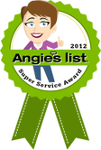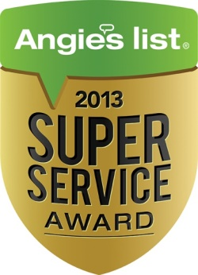
We comply with the only process approved by the Asphalt Roofing Manufacturer's Association,
GAF, CertainTeed, TAMKO and Owens Corning
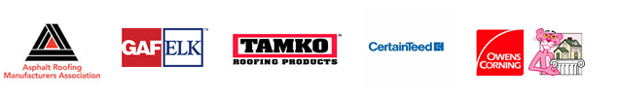

Payment due upon completion unless otherwise arranged in advance
A veteran owned and operated business
Licensed and Insured

